**OS**

**UNIT II**

**PROCESS MANAGEMENT**

**Process Management in OS**

A Program does nothing unless its instructions are executed by a CPU. A program in execution is called a process. In order to accomplish its task, process needs the computer resources.

There may exist more than one process in the system which may require the same resource at the same time. Therefore, the operating system has to manage all the processes and the resources in a convenient and efficient way.

Some resources may need to be executed by one process at one time to maintain the consistency otherwise the system can become inconsistent and deadlock may occur.

The operating system is responsible for the following activities in connection with Process Management

1. Scheduling processes and threads on the CPUs.
2. Creating and deleting both user and system processes.
3. Suspending and resuming processes.
4. Providing mechanisms for process synchronization.
5. Providing mechanisms for process communication.

# Attributes of a process

The Attributes of the process are used by the Operating System to create the process control block (PCB) for each of them. This is also called context of the process. Attributes which are stored in the PCB are described below.

### 1. Process ID

When a process is created, a unique id is assigned to the process which is used for unique identification of the process in the system.

### 2. Program counter

A program counter stores the address of the last instruction of the process on which the process was suspended. The CPU uses this address when the execution of this process is resumed.

### 3. Process State

The Process, from its creation to the completion, goes through various states which are new, ready, running and waiting. We will discuss about them later in detail.

### 4. Priority

Every process has its own priority. The process with the highest priority among the processes gets the CPU first. This is also stored on the process control block.

### 5. General Purpose Registers

Every process has its own set of registers which are used to hold the data which is generated during the execution of the process.

### 6. List of open files

During the Execution, Every process uses some files which need to be present in the main memory. OS also maintains a list of open files in the PCB.

### 7. List of open devices

OS also maintain the list of all open devices which are used during the execution of the process.

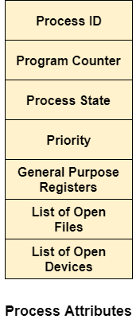

## **What is saved in the Process Control Block?**

The Operating system maintains a process control block during the lifetime of the process. The Process control block is deleted when the process is terminated or killed. There is the following information which is saved in the process control block and is changing with the state of the process.

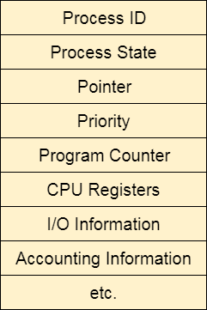

**PROCESS SCHEDULING**

# CPU Scheduling

**In the uniprogrammming systems** like MS DOS, when a process waits for any I/O operation to be done, the CPU remains idol. This is an overhead since it wastes the time and causes the problem of starvation. However, In Multiprogramming systems, the CPU doesn't remain idle during the waiting time of the Process and it starts executing other processes. Operating System has to define which process the CPU will be given.

**In Multiprogramming systems**, the Operating system schedules the processes on the CPU to have the maximum utilization of it and this procedure is called **CPU scheduling**. The Operating System uses various scheduling algorithm to schedule the processes.

This is a task of the short term scheduler to schedule the CPU for the number of processes present in the Job Pool. Whenever the running process requests some IO operation then the short term scheduler saves the current context of the process (also called PCB) and changes its state from running to waiting. During the time, process is in waiting state; the Short term scheduler picks another process from the ready queue and assigns the CPU to this process. This procedure is called **context switching**.

## **Why do we need Scheduling?**

In Multiprogramming, if the long term scheduler picks more I/O bound processes then most of the time, the CPU remains idol. The task of Operating system is to optimize the utilization of resources.

If most of the running processes change their state from running to waiting then there may always be a possibility of deadlock in the system. Hence to reduce this overhead, the OS needs to schedule the jobs to get the optimal utilization of CPU and to avoid the possibility to deadlock.

**Ppreemptive and Non preemptive**

In preemptive scheduling, the CPU is allocated to the processes for a limited time whereas, in Non-preemptive scheduling, the CPU is allocated to the process till it terminates or switches to the waiting state

Non-preemptive Scheduling is a CPU scheduling technique the process takes the resource (CPU time) and holds it till the process gets terminated or is pushed to the waiting state. No process is interrupted until it is completed, and after that processor switches to another process

In the Non Preemptive Priority scheduling, The Processes are scheduled according to the priority number assigned to them. Once the process gets scheduled, it will run till the completion. Generally, the lower the priority number, the higher is the priority of the process. The people might get confused with the priority numbers, hence in the GATE, there clearly mention which one is the highest priority and which one is the lowest one.

# Scheduling Algorithms

There are various algorithms which are used by the Operating System to schedule the processes on the processor in an efficient way.

## The Purpose of a Scheduling algorithm

1. Maximum CPU utilization
2. Fare allocation of CPU
3. Maximum throughput
4. Minimum turnaround time
5. Minimum waiting time
6. Minimum response time

There are the following algorithms which can be used to schedule the jobs.

### 1. First Come First Serve

It is the simplest algorithm to implement. The process with the minimal arrival time will get the CPU first. The lesser the arrival time, the sooner will the process gets the CPU. It is the non-preemptive type of scheduling.

### 2. Round Robin

In the Round Robin scheduling algorithm, the OS defines a time quantum (slice). All the processes will get executed in the cyclic way. Each of the process will get the CPU for a small amount of time (called time quantum) and then get back to the ready queue to wait for its next turn. It is a preemptive type of scheduling.

### 3. Shortest Job First

The job with the shortest burst time will get the CPU first. The lesser the burst time, the sooner will the process get the CPU. It is the non-preemptive type of scheduling.

### 4. Shortest remaining time first

It is the preemptive form of SJF. In this algorithm, the OS schedules the Job according to the remaining time of the execution.

### 5. Priority based scheduling

In this algorithm, the priority will be assigned to each of the processes. The higher the priority, the sooner will the process get the CPU. If the priority of the two processes is same then they will be scheduled according to their arrival time.

### 6. Highest Response Ratio Next

In this scheduling Algorithm, the process with highest response ratio will be scheduled next. This reduces the starvation in the system.

# FCFS Scheduling

**First come first serve** (FCFS) scheduling algorithm simply schedules the jobs according to their arrival time. The job which comes first in the ready queue will get the CPU first. The lesser the arrival time of the job, the sooner will the job get the CPU. FCFS scheduling may cause the problem of starvation if the burst time of the first process is the longest among all the jobs.

## Advantages of FCFS

* Simple
* Easy
* First come, First serv

## Disadvantages of FCFS

1. The scheduling method is non preemptive, the process will run to the completion.
2. Due to the non-preemptive nature of the algorithm, the problem of starvation may occur.
3. Although it is easy to implement, but it is poor in performance since the average waiting time is higher as compare to other scheduling algorithms.

### Example

Let's take an example of The FCFS scheduling algorithm. In the Following schedule, there are 5 processes with process ID **P0, P1, P2, P3 and P4**. P0 arrives at time 0, P1 at time 1, P2 at time 2, P3 arrives at time 3 and Process P4 arrives at time 4 in the ready queue. The processes and their respective Arrival and Burst time are given in the following table.

The Turnaround time and the waiting time are calculated by using the following formula.

1. Turn Around Time = Completion Time - Arrival Time
2. Waiting Time = Turnaround time - Burst Time

The average waiting Time is determined by summing the respective waiting time of all the processes and divided the sum by the total number of processes.

# Shortest Job First (SJF) Scheduling

Till now, we were scheduling the processes according to their arrival time (in FCFS scheduling). However, SJF scheduling algorithm, schedules the processes according to their burst time.

In SJF scheduling, the process with the lowest burst time, among the list of available processes in the ready queue, is going to be scheduled next.

However, it is very difficult to predict the burst time needed for a process hence this algorithm is very difficult to implement in the system

## Advantages of SJF

1. Maximum throughput
2. Minimum average waiting and turnaround time

## Disadvantages of SJF

1. May suffer with the problem of starvation
2. It is not implementable because the exact Burst time for a process can't be known in advance.

There are different techniques available by which, the CPU burst time of the process can be determined.

# Round Robin Scheduling Algorithm

Round Robin scheduling algorithm is one of the most popular scheduling algorithm which can actually be implemented in most of the operating systems. This is the **preemptive version** of first come first serve scheduling. The Algorithm focuses on Time Sharing. In this algorithm, every process gets executed in a **cyclic way**. A certain time slice is defined in the system which is called time **quantum**. Each process present in the ready queue is assigned the CPU for that time quantum, if the execution of the process is completed during that time then the process will **terminate** else the process will go back to the **ready queue** and waits for the next turn to complete the execution.

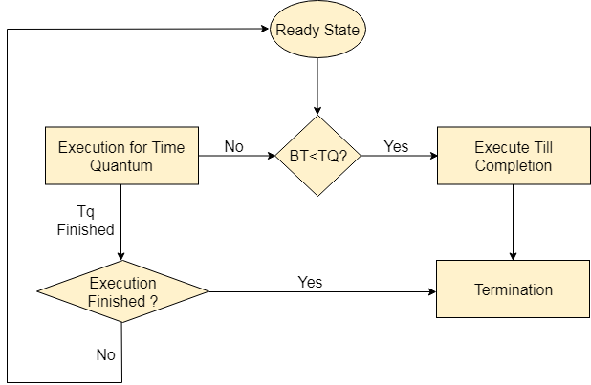

## Advantages

1. It can be actually implementable in the system because it is not depending on the burst time.
2. It doesn't suffer from the problem of starvation or convoy effect.
3. All the jobs get a fare allocation of CPU.

## Disadvantages

1. The higher the time quantum, the higher the response time in the system.
2. The lower the time quantum, the higher the context switching overhead in the system.
3. Deciding a perfect time quantum is really a very difficult task in the system.

**Inter Process Communication (IPC)**

The full form of IPC is **Inter-process communication**. It is a set of programming interface which allow a programmer to coordinate activities among various program processes which can run concurrently in an operating system. This allows a specific program to handle many user requests at the same time

A process can be of two types:

* Independent process.
* Co-operating process.

An independent process is not affected by the execution of other processes while a co-operating process can be affected by other executing processes. Though one can think that those processes, which are running independently, will execute very efficiently, in reality, there are many situations when co-operative nature can be utilized for increasing computational speed, convenience, and modularity. Inter-process communication (IPC) is a mechanism that allows processes to communicate with each other and synchronize their actions. The communication between these processes can be seen as a method of co-operation between them. Processes can communicate with each other through both:

1. Shared Memory
2. Message passing

**Thread (computing) :**

In computing· Threads made an early appearance under the name of "tasks" in OS at the kernel level, a process contains one or more kernel threads.

A thread is a single sequential flow of execution of tasks of a process so it is also known as thread of execution or thread of control. There is a way of thread execution inside the process of any operating system. Apart from this, there can be more than one thread inside a process

**Implicit Threads**

Implicit threading is the use of libraries or other language support to hide the management of threads. In the context of C, the most common implicit threading library is OpenMP. OpenMP uses the #pragma compiler directive to detect and insert additional library code at compile time.

**Multithreaded Model**

Multithreading Model: Multithreading allows the application to divide its task into individual threads. In multi-threads, the same process or task can be done by the number of threads, or we can say that there is more than one thread to perform the task in multithreading.

Multithreading issues

Unpredictable results− Multithreaded programs can sometimes lead to unpredictable results as they are essentially multiple parts of a program that are running at the same time. Complications for Porting Existing Code − A lot of testing is required for porting existing code in multithreading

**Threading issues**

Threading issues with system calls, cancellation of thread, signal handling, thread pool and thread-specific data.

* The fork() and exec() System Calls. The fork() and exec() are the system calls.
* Thread cancellation.
* Signal Handling.
* Thread Pool.
* Thread Specific data.